Project Planning Phase
Project Planning Template (Product Backlog, Sprint Planning, Stories, Story points)

Date | [DD Month YYYY]
Team ID | [Team ID]
Project Name | Automated Network Request Management in ServiceNow
Maximum Marks | 5 Marks

Product Backlog, Sprint Schedule, and Estimation (4 Marks)
Use the below template to create product backlog and sprint schedule
Sprint | Functional Requirement (Epic) | User Story Number | User Story / Task | Story Points | Priority | Team Members
Sprint-1 | Catalog Item Setup | USN-1 | As a requester, I can find the Network Request item in the Service Catalog under the Network category. | 2 | High | [Name(s)]
Sprint-1 | Catalog Item Setup | USN-2 | As a requester, I can enter Requested For, Mobile Number, Type of Connection, Total Amount, Mode of Payment and Address and submit the request. | 3 | High | [Name(s)]
Sprint-1 | Catalog Item Setup | USN-3 | As a requester, my Email and User Name are filled automatically from the Requester Information variable set. | 2 | Medium | [Name(s)]
Sprint-1 | Catalog Item Setup | USN-4 | As a requester, I see the 'Enter your existing id' field only when I choose an Existing connection. | 2 | High | [Name(s)]
Sprint-1 | Data Model | USN-5 | As an administrator, each network request is stored in the Database Tables (u_database_table) table. | 3 | High | [Name(s)]
Sprint-1 | Data Model | USN-6 | As an approver, I can see the approval records that belong to a Database Tables record. | 2 | Medium | [Name(s)]
Sprint-2 | Flow Automation | USN-7 | As an administrator, the Network Request Automation flow starts automatically when the Network Request item is requested and retrieves the catalog variables. | 3 | High | [Name(s)]
Sprint-2 | Flow Automation | USN-8 | As an administrator, the flow creates a Database Tables record from the submitted catalog values. | 3 | High | [Name(s)]
Sprint-2 | Notification | USN-9 | As a requester, I am notified that my request has been received and is pending approval. | 2 | Medium | [Name(s)]
Sprint-2 | Approval | USN-10 | As an approver, I receive an approval request for every new network request. | 3 | High | [Name(s)]
Sprint-2 | Approval | USN-11 | As an administrator, the request status is updated to Approved or Rejected according to the decision. | 3 | High | [Name(s)]
Sprint-3 | Fulfilment | USN-12 | As a Network Team member, I can work on and close the catalog task for the request. | 2 | Medium | [Name(s)]
Sprint-3 | Testing & Evidence | USN-13 | As the project team, we test the end-to-end process and capture evidence for each test case. | 3 | High | [Name(s)]
Sprint-3 | Documentation & Demo | USN-14 | As the project team, we prepare documentation, a demonstration video and a GitHub submission. | 3 | Medium | [Name(s)]

Story points use the Fibonacci scale from 'Planning logic.docx' (1 very easy, 2 normal, 3 moderate, 5 difficult). They are the team's estimates, reconstructed for documentation; adjust them if your sprint records differ.

Project Tracker, Velocity & Burndown Chart: (4 Marks)
Sprint | Total Story Points | Duration | Sprint Start Date | Sprint End Date (Planned) | Story Points Completed (as on Planned End Date) | Sprint Release Date (Actual)
Sprint-1 | 14 | [N days] | [Start date] | [Planned end date] | 14 | [Actual release date]
Sprint-2 | 14 | [N days] | [Start date] | [Planned end date] | 11 (USN-8 carried over) | [Actual release date]
Sprint-3 | 8 | [N days] | [Start date] | [Planned end date] | 2 (in progress) | In progress

Velocity:
Imagine we have a 10-day sprint duration, and the velocity of the team is 20 (points per sprint). Let’s calculate the team’s average velocity (AV) per iteration unit (story points per day)

Velocity for this project: total backlog = 36 story points over 3 sprints. Story points completed: Sprint-1 = 14 of 14; Sprint-2 = 11 of 14 (USN-8 is carried over because its acceptance criterion fails — Create Record mapping defect BG-03).
Velocity = Total story points completed / Number of completed sprints = (14 + 11) / 2 = 12.5 story points per sprint.
Average velocity per day: AV = Velocity / D = 12.5 / D story points per day, where D is the sprint duration in days (sprint dates were not recorded).
Sprint-3 is in progress: USN-12 (catalog task closure, 2 SP) is complete; USN-8 (carry-over), USN-13 (testing and evidence) and USN-14 (documentation, demo and GitHub) are open.

Burndown Chart:
A burn down chart is a graphical representation of work left to do versus time. It is often used in agile software development methodologies such as Scrum. However, burn down charts can be applied to any project containing measurable progress over time.

https://www.visual-paradigm.com/scrum/scrum-burndown-chart/
https://www.atlassian.com/agile/tutorials/burndown-charts

Burndown chart — Automated Network Request Management
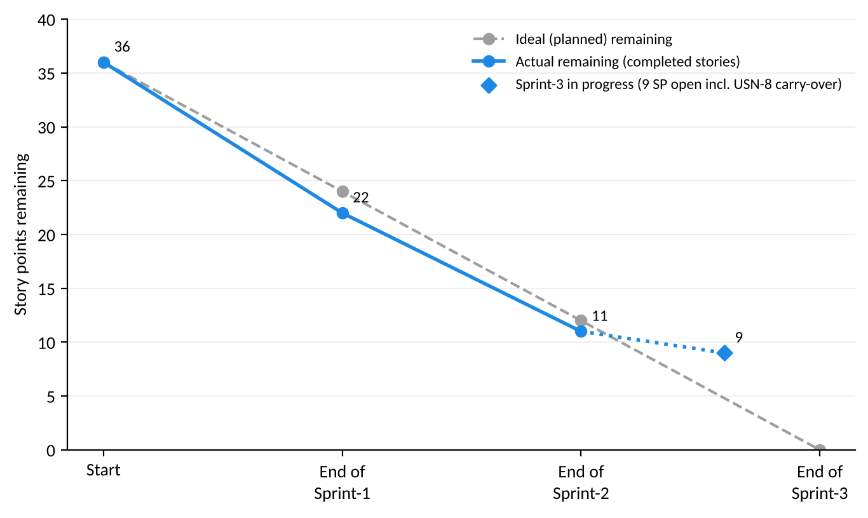
Figure 1: Story points remaining by sprint (ideal vs actual)

Reference:
https://www.atlassian.com/agile/project-management
https://www.atlassian.com/agile/tutorials/how-to-do-scrum-with-jira-software
https://www.atlassian.com/agile/tutorials/epics
https://www.atlassian.com/agile/tutorials/sprints
https://www.atlassian.com/agile/project-management/estimation
https://www.atlassian.com/agile/tutorials/burndown-charts

